

null 2

2

null



t 1

|  |  |  |  |  |  |  |  |  |  |  |  |  |  |  |  |  |  |
| --- | --- | --- | --- | --- | --- | --- | --- | --- | --- | --- | --- | --- | --- | --- | --- | --- | --- |
|  |  |  |  |  |  |  |  |  |  |  |  |  |  |  |  |  |  |
| E | l | e | c | t | r | o | c | a | r | d | i | o | g | r | a | m | a |

|  |  |  |  |  |  |  |  |  |  |  |
| --- | --- | --- | --- | --- | --- | --- | --- | --- | --- | --- |
| 2 | 1 | 2 | 1 | 3 | 2 | 3 | 1 | 1 | 1 | 1 |
| E | l | c | t | r | O | a | d | i | g | m |

|  |  |  |  |  |  |  |  |  |  |  |
| --- | --- | --- | --- | --- | --- | --- | --- | --- | --- | --- |
| 1 | 1 | 1 | 1 | 1 | 1 | 2 | 2 | 2 | 3 | 3 |
| L | t | d | i | g | m | e | c | o | r | a |



|  |  |
| --- | --- |
| L | 1 |

|  |  |
| --- | --- |
| t | 1 |

|  |  |
| --- | --- |
| d | 1 |

|  |  |
| --- | --- |
| i | 1 |

|  |  |
| --- | --- |
| g | 1 |

|  |  |
| --- | --- |
| m | 1 |

|  |  |
| --- | --- |
| e | 2 |

|  |  |
| --- | --- |
| c | 2 |

|  |  |
| --- | --- |
| o | 2 |

|  |  |
| --- | --- |
| r | 3 |

|  |  |
| --- | --- |
| a | 3 |

|  |  |
| --- | --- |
| null | 2 |

|  |  |
| --- | --- |
| L | 1 |

|  |  |
| --- | --- |
| t | 1 |

|  |  |
| --- | --- |
| d | 1 |

|  |  |
| --- | --- |
| i | 1 |

|  |  |
| --- | --- |
| g | 1 |

|  |  |
| --- | --- |
| m | 1 |

|  |  |
| --- | --- |
| e | 2 |

|  |  |
| --- | --- |
| c | 2 |

|  |  |
| --- | --- |
| o | 2 |

|  |  |
| --- | --- |
| r | 3 |

|  |  |
| --- | --- |
| a | 3 |

|  |  |
| --- | --- |
| null | 2 |

|  |  |
| --- | --- |
| L | 1 |

1

t

|  |  |
| --- | --- |
| null | 2 |

|  |  |
| --- | --- |
| d | 1 |

|  |  |
| --- | --- |
| i | 1 |



|  |  |
| --- | --- |
| g | 1 |

|  |  |
| --- | --- |
| m | 1 |

|  |  |
| --- | --- |
| e | 2 |

|  |  |
| --- | --- |
| c | 2 |

|  |  |
| --- | --- |
| o | 2 |

|  |  |
| --- | --- |
| r | 3 |

|  |  |
| --- | --- |
| a | 3 |

|  |  |
| --- | --- |
|  |  |
| L | 1 |

d

1

|  |  |
| --- | --- |
|  |  |
| i | 1 |



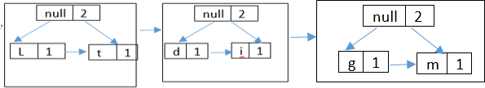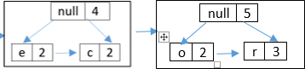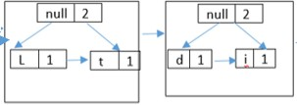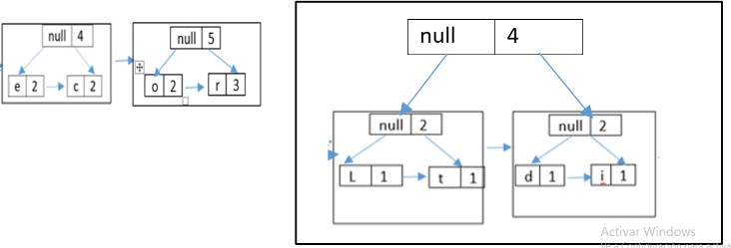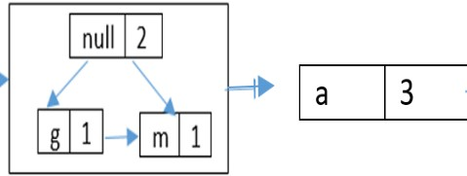

|  |  |
| --- | --- |
| g | 1 |

|  |  |
| --- | --- |
| m | 1 |

|  |  |
| --- | --- |
| o | 2 |

|  |  |
| --- | --- |
| r | 3 |

|  |  |
| --- | --- |
|  |  |

|  |  |
| --- | --- |
|  |  |

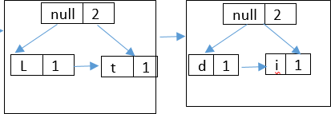

|  |  |
| --- | --- |
| e | 2 |

|  |  |
| --- | --- |
| c | 2 |

|  |  |
| --- | --- |
| o | 2 |

|  |  |
| --- | --- |
| r | 3 |

|  |  |
| --- | --- |
| a | 3 |

|  |  |
| --- | --- |
| null | 2 |

|  |  |
| --- | --- |
| o | 2 |

|  |  |
| --- | --- |
| r | 3 |

|  |  |
| --- | --- |
| a | 3 |

|  |  |  |  |
| --- | --- | --- | --- |
|  | null | 4 |  |
| e 2 c 2 | | | |

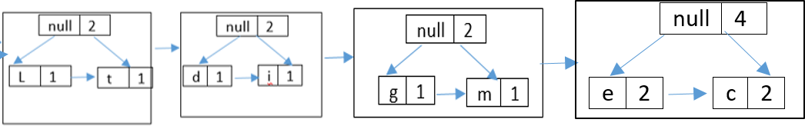

|  |  |
| --- | --- |
| a | 3 |

|  |  |
| --- | --- |
| null | 5 |

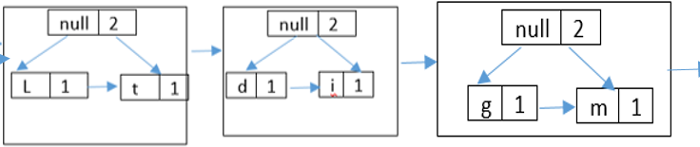

|  |  |
| --- | --- |
| a | 3 |

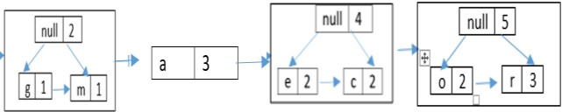

|  |  |
| --- | --- |
| null | 4 |

|  |  |
| --- | --- |
| null | 5 |



|  |  |
| --- | --- |
| null | 9 |

000 1000 000 011 1001 111 001 011 110 111 0100 1010 001 0101 111 110

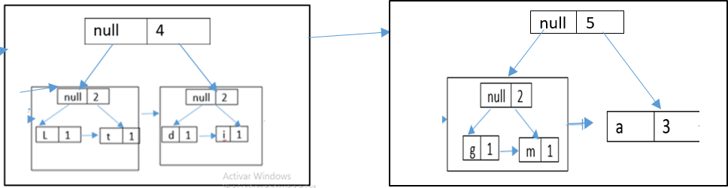

1011 110

